Chapter 6, Problem 65.

The inductors in Fig. 6.87 are initially charged and are connected to the black box at t = 0. If i₁(0) = 4 A, i₂(0) = -2 A, and v(t) = 50e^{-200t} mV, t ≥ 0$, find:

- the energy initially stored in each inductor,
- the total energy delivered to the black box from t = 0 to t = ∞,
- i₁(t) and i₂(t), t ≥ 0,
- i(t), t ≥ 0.

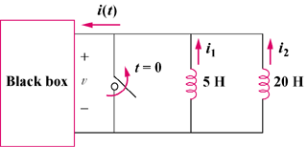

Figure 6.87
For Prob. 6.65.

